**Task 19: Establishing a connection between different Virtual Private Clouds Using AWS VPC Peering**

VPC peering is a networking connection between two Virtual Private Clouds (VPCs) that enables them to communicate directly over private IP addresses. It allows traffic between the VPCs without going over the public internet, enhancing security and reducing latency.

**1. Created 2 VPCs named VPC_01 & VPC_02**

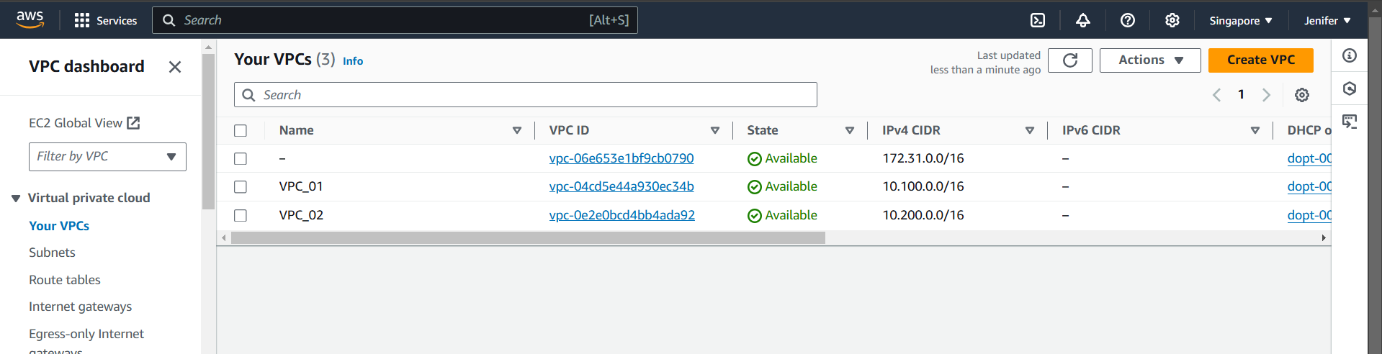

**2. Created 2 Subnets for VPC_01**

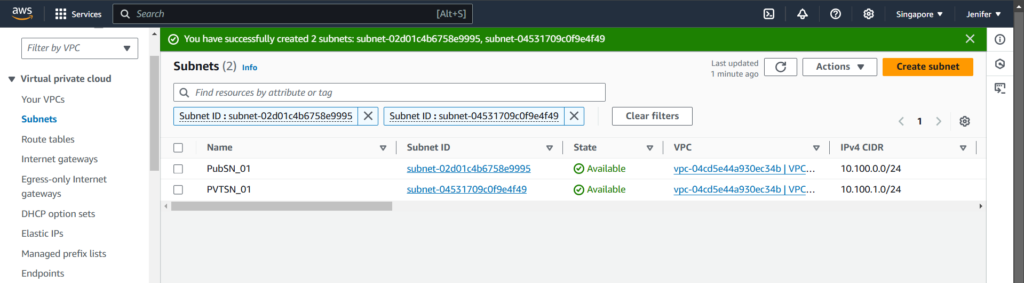

**3. Created 2 Route Tables for VPC_01**

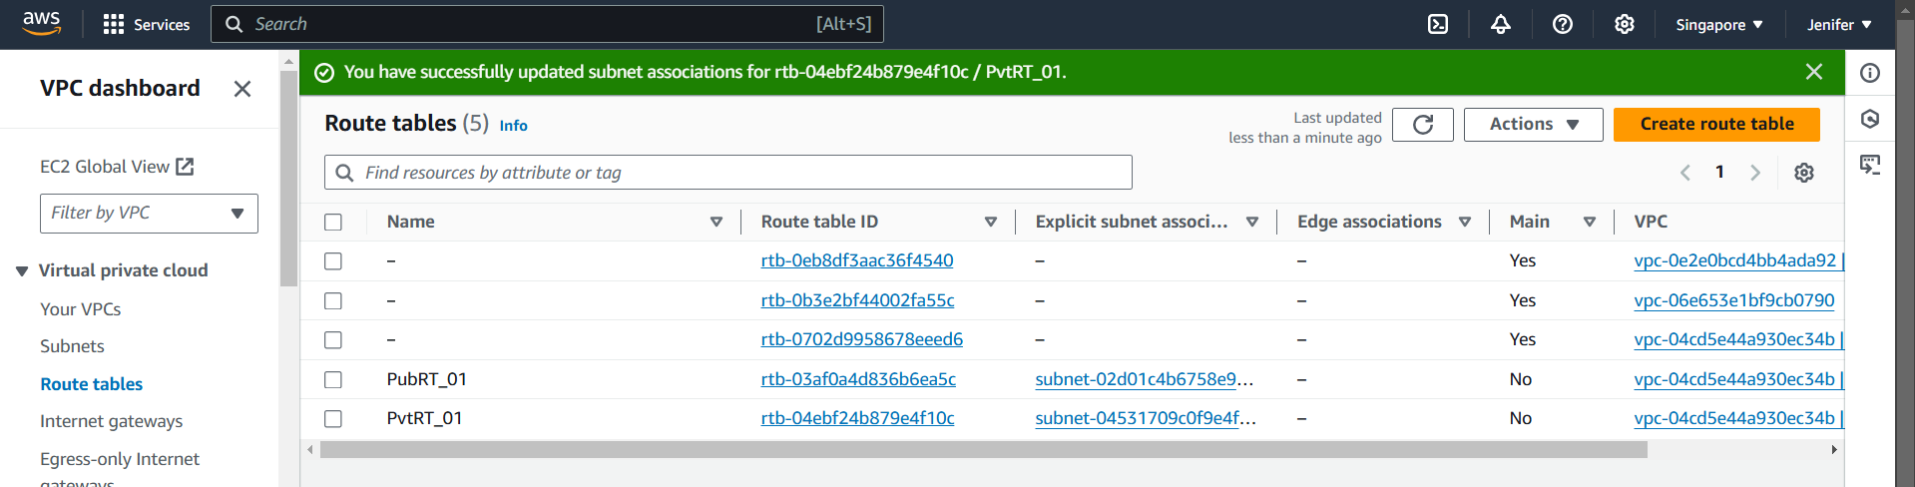

**4. Created Internet Gateway & Attached to VPC_01**

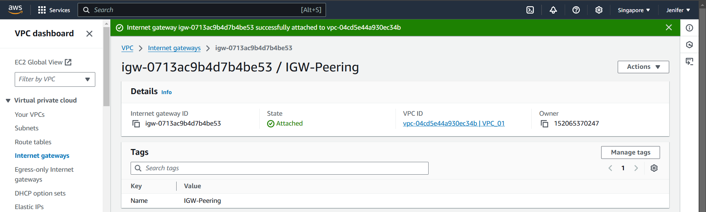

**5. Launched EC2 Instance in Public Subnet & Checked the Internet Connectivity**

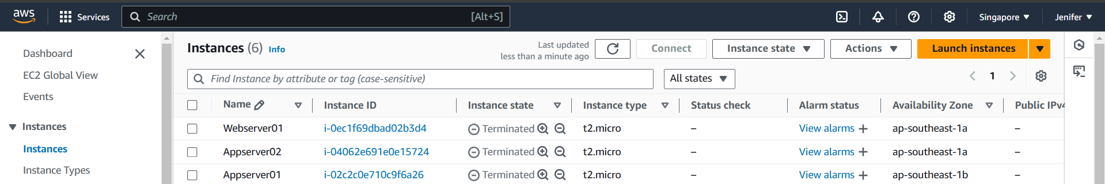

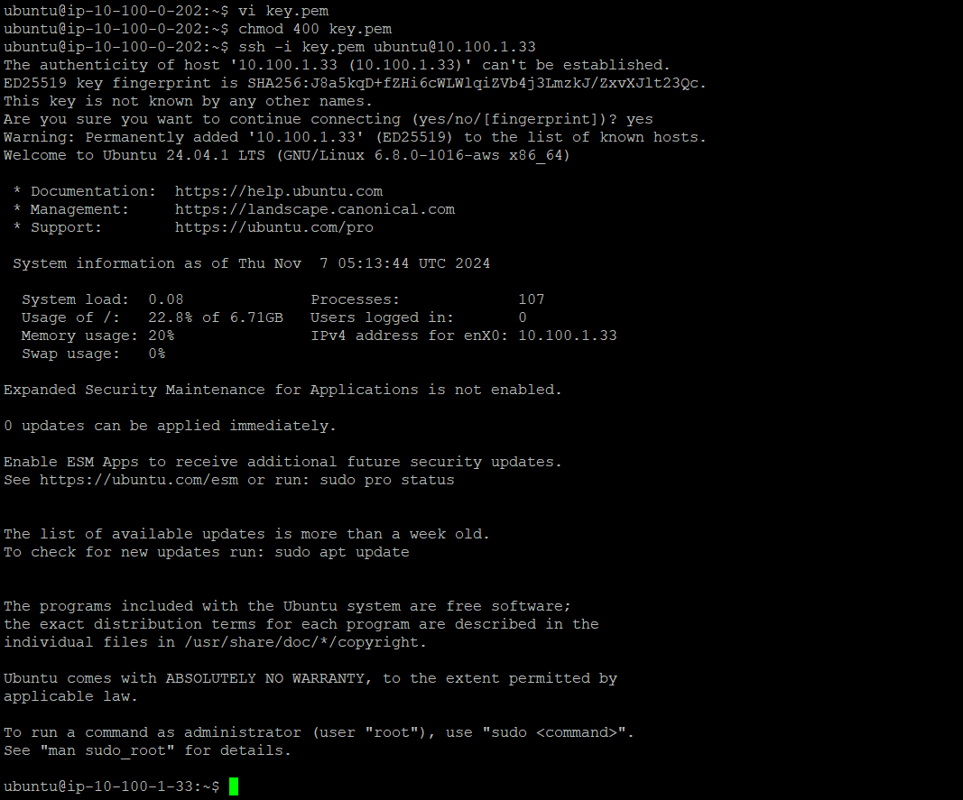

**5. Requested for Peering Connection from VPC_01 to VPC_02**

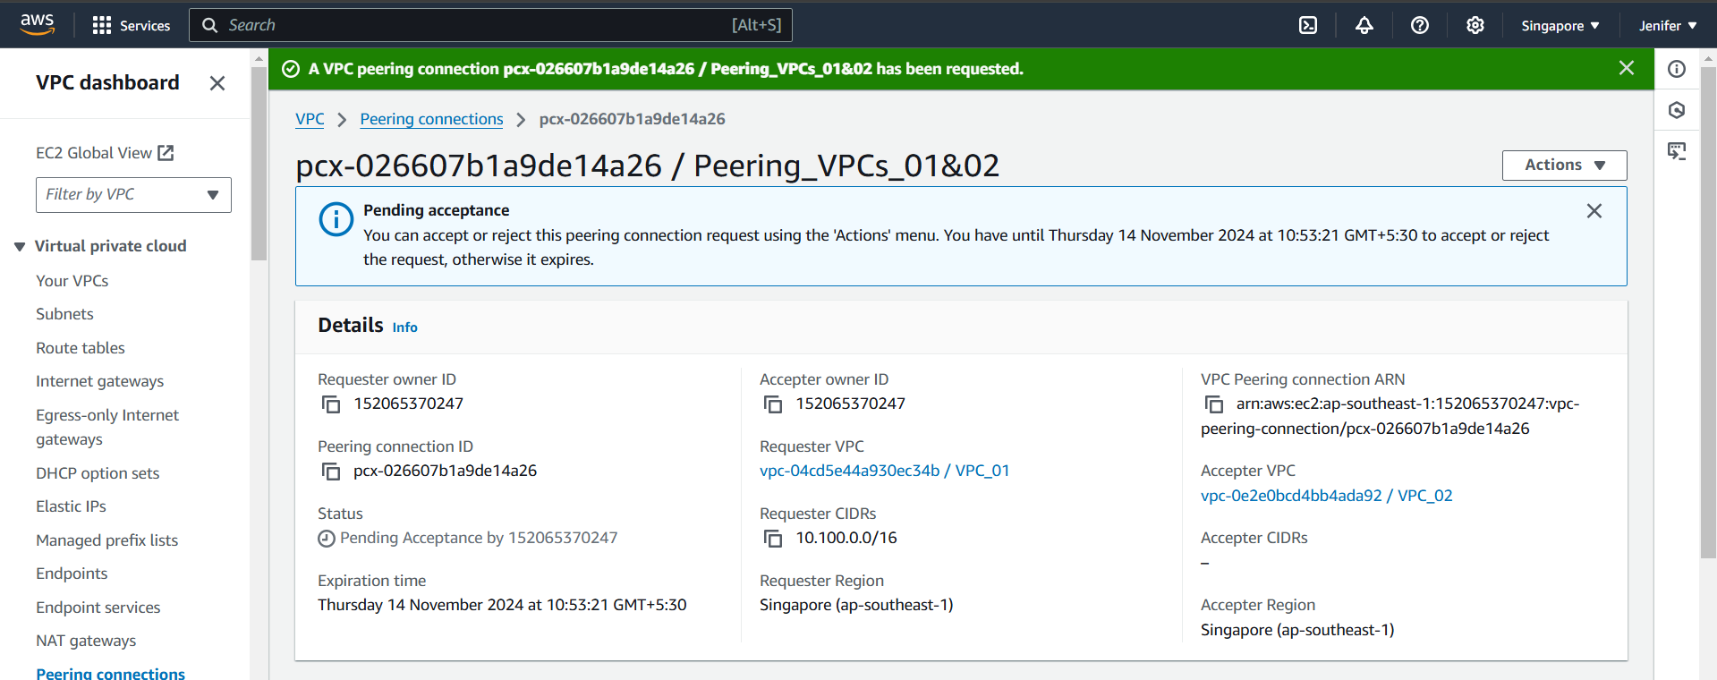

**6. Peering Connection got established**

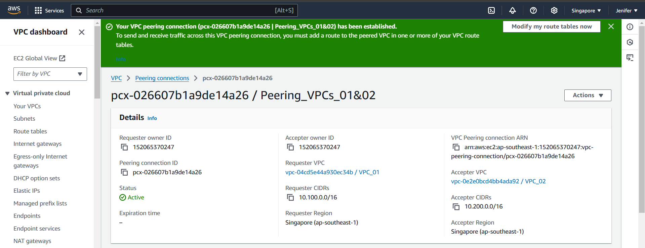

**7. Created Subnet for VPC_02**

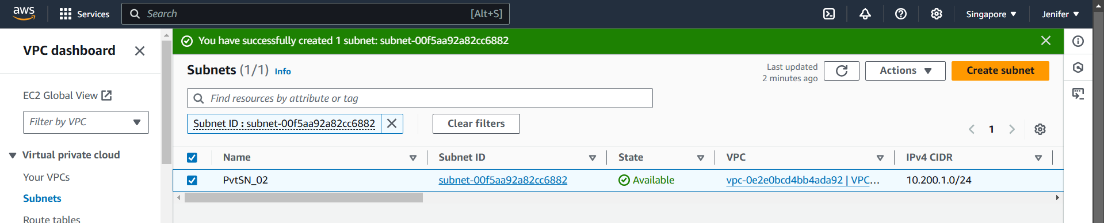

**8. Created Route Table and Completed the Subnet Association for VPC_02**

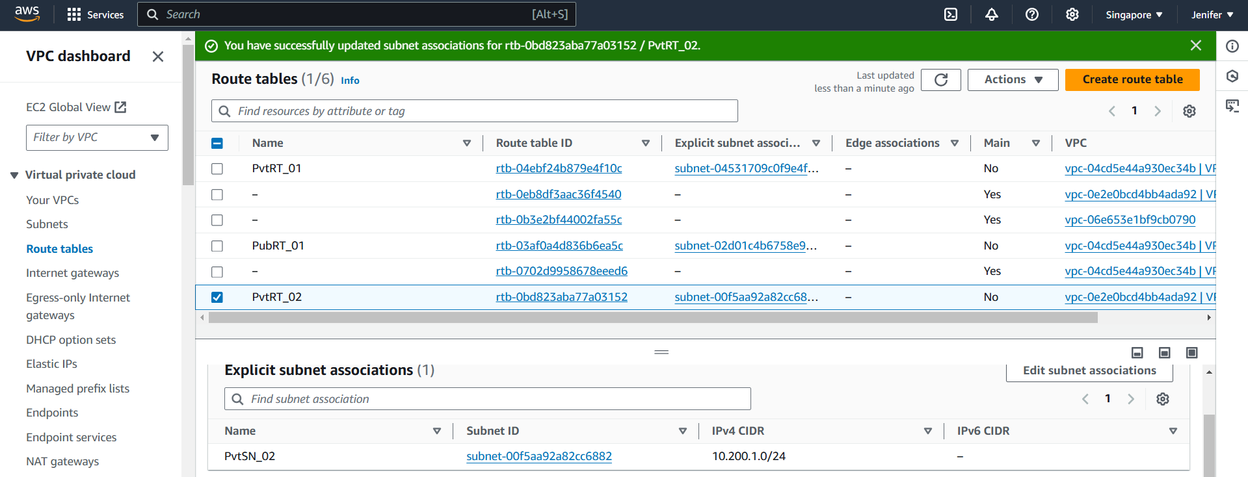

**9. Edited the Routes for establishing connections from VPC_01’s Private Subnet’s RT to VPC_02’s Private Subnet’s RT**

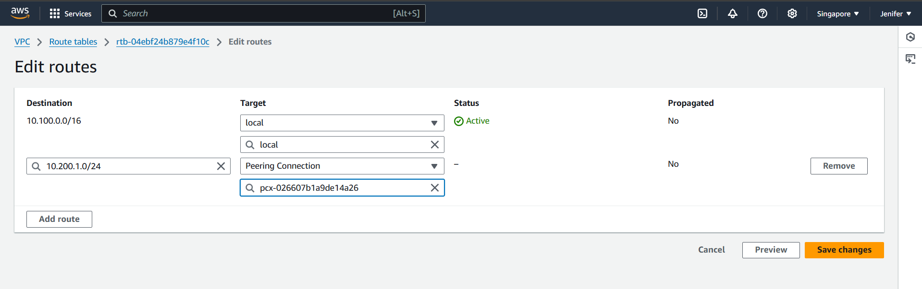

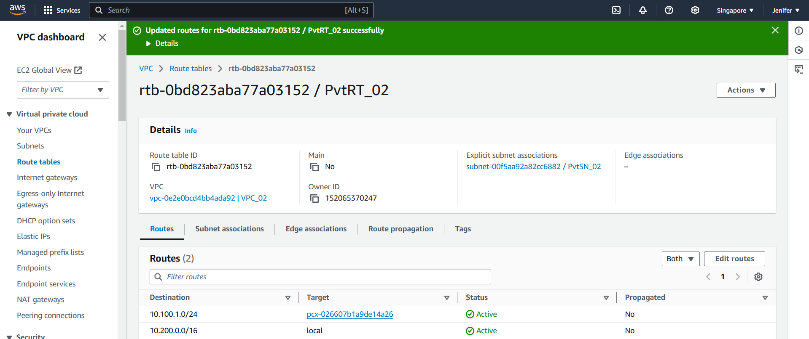

**10. Successfully Jumped into the Appserver01 from Webserver01 using ssh**



**11. Successfully Jumped into the Appserver02 from Appserver01 & Installed git in Appserver02**

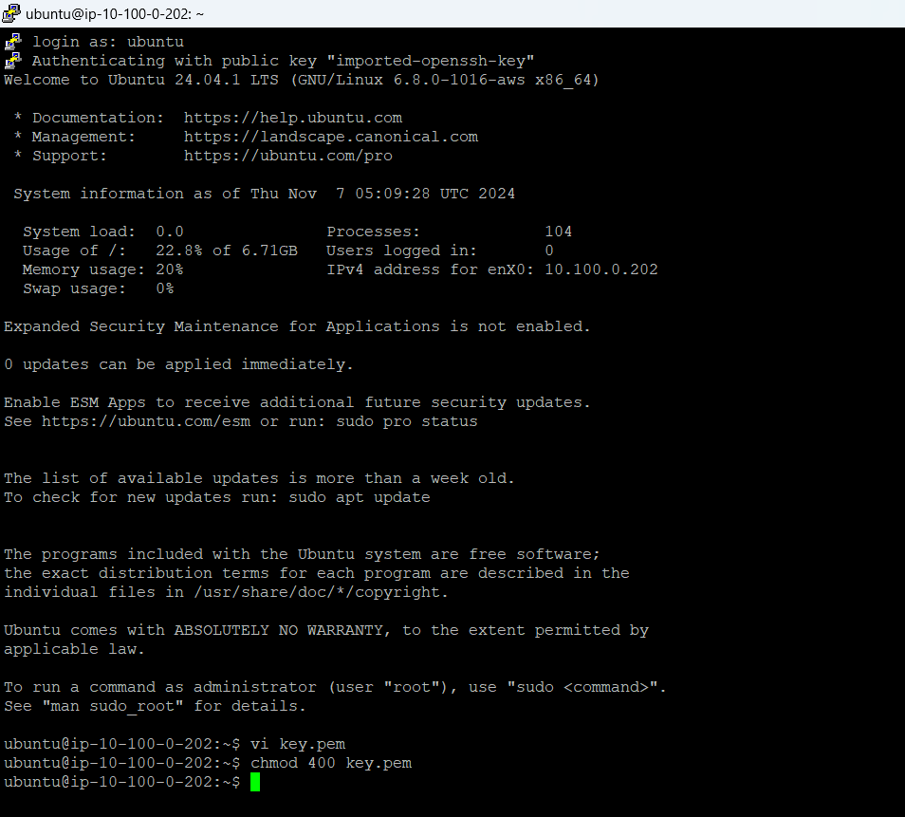



**12. Logged Out from all the servers one by one**

